Software Process Selection, Project Plan and Risk Management

P07: Automated Compliance Auditing Software integrated with Ai

<team member names & ids>

Student ID | Name
25100132 | Shabbir Kamal
25100277 | Ammad Akram
25100279 | Rida Bilgrami
25100162 | Syed Aqdas Rizvi

Table of Contents

1. Introduction 3
2. Software Process Selection 4
3. Gantt Chart 5
4. Development Environment Preparation 6
5. Deployment Platform 6
6. Risk Management 7
6.1 Potential Risks and Mitigation Strategies 7
7. Who Did What? 8
8. Review checklist 8

Introduction

<Give an overview of the project here. The overview must highlight the overall objectives of the project and its potential users and customers.>

Overview: ACASA (Automated Compliance Auditing Software using AI) aims to automate the auditing of compliance standards such as HIPAA, ISO 27001, PCI-DSS, and GDPR. It utilizes open-source libraries and AI-driven decision-making to address current market gaps, particularly by offering a cost-effective, fully automated solution. ACASA targets organizations needing to streamline compliance processes, reducing human intervention and error, while improving audit accuracy and efficiency.

Potential Users:

Compliance Officers

IT Security Teams

Executives

Auditors

Software Process Selection

< (1) Discuss a pros and cons of waterfall and agile (scrum) processes in your own words.
(2) Select one of the above processes for your project development.
(3) Justify your selection with clear reasoning. Refer to “Project Context Analysis” in the slides to get help for writing this section.>

- Comparison of Waterfall vs. Agile (Scrum) for ACASA
Waterfall Process Pros and Cons:
- Pros:
  - Waterfall Process has a clear structure and it works well when requirements are clearly understood upfront.
  - The extensive documentation ensures that the project will follow a fixed path, which could be helpful for compliance-heavy systems like ACASA.
  - Clear milestones provide a clear understanding of project progress, as each phase needs to be completed before the next starts.
- Cons:
  - Rigidity in changing requirements can be difficult to handle. ACASA involves AI and security technologies, which may require changes as technologies evolve rapidly or customer needs shift.
  - The long feedback cycle and limited customer feedback until the later phases, is a disadvantageous for systems like ACASA that need to adapt to user feedback in their early stages.
Agile (Scrum) Pros and Cons:
- Pros:
  - Agile has more Flexibility allowing for iterative development, which is ideal for ACASA as the compliance requirements or AI models may evolve overtime.
  - Faster feedback and continuous user involvement/feedback make it possible to adjust the system to user needs, proving beneficial for a tool like ACASA used by compliance officers and IT security teams.
  - Focus on customer satisfaction and Agile’s incremental approach allows the team to release working software early and make adjustments based on real-world use.
- Cons:
  - It requires active user involvement as Agile needs the active involvement of the project stakeholders, which might not always be feasible.
  - This could lead to scope creep meaning that the flexibility might lead to scope changes, which could delay the completion if not managed properly.
- Selected Process: Agile (Scrum)

- Justification:
- Adapting to Changing Requirements:
- ACASA is a compliance auditing system, and the nature of compliance standards like HIPAA, ISO 27001, PCI-DSS, and GDPR is that they evolve over time. An agile approach like Scrum allows the team to welcome changes even late in development, ensuring that ACASA remains compliant with the latest standards.
- Iterative Development with Early Feedback:
- ACASA's modular architecture (layered, client-server, and API-driven) aligns perfectly with Scrum’s iterative nature. By delivering working software in sprints, the team can gather early feedback on the dashboard interface, AI module accuracy, and security tools integration from compliance officers and IT admins. This reduces the risk of delivering a final product that doesn't meet user needs.
- Flexibility and Scalability:
- The system is built with external APIs and modular AI components, allowing for flexibility. If new compliance clauses or requirements arise, Scrum facilitates easier integration of these elements in future sprints without needing to redesign the entire system, which would be harder in a plan-driven or waterfall approach.
- Supporting Non-functional Requirements:
- Non-functional requirements like system performance, security, and scalability are critical for ACASA. Scrum allows continuous attention to these through iterative testing and improvements, ensuring that the system can handle large datasets, complex AI analysis, and secure document storage as required by the project.

Gantt chart

<Draw a Gantt chart that illustrates your project’s schedule. The Gantt chart should show at least the following

- Tasks (tasks should not be too small or too large)
- Duration (in weeks)
- Milestones
- Team member names who are going to work on each task.
>

The Gantt chart should include both the activities that you have already completed and those that you would be doing in the future.

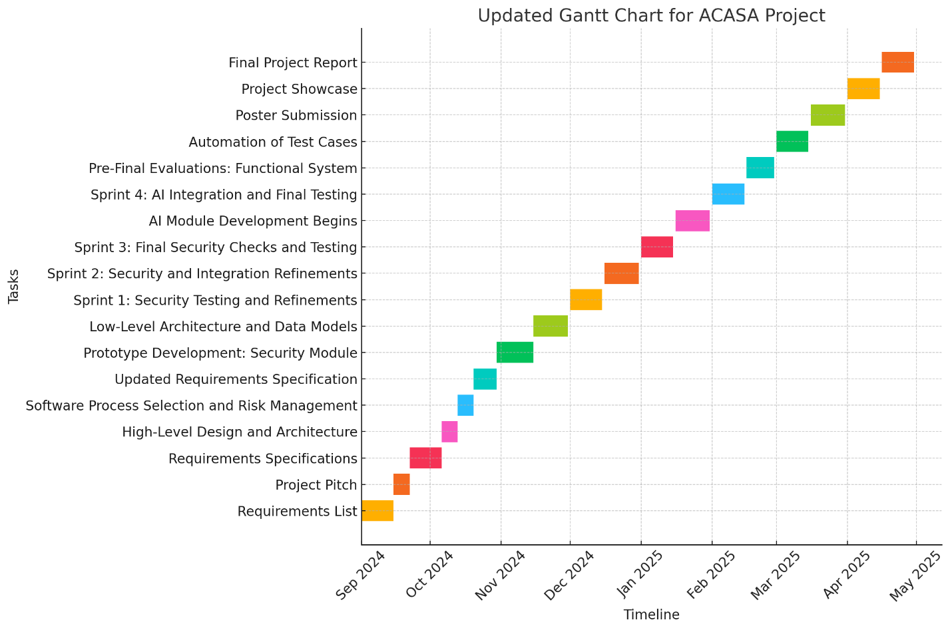

Description about Gantt chart:

Task | Start Date | End Date | Team Member(s) | Detailed Responsibilities | Milestone
Requirements List | 01-Sep-2024 | 15-Sep-2024 | All Members | Shabbir Kamal and Ammad Akram focus on defining security tool integration requirements. Aqdas Rizvi handles software-related requirements, and Rida Bilgrami works on compliance needs. | Requirements list completed
Project Pitch | 15-Sep-2024 | 22-Sep-2024 | All Members | Shabbir Kamal presents the security tool integrations. Ammad Akram supports with security-related aspects. Aqdas Rizvi presents the high-level architecture, and Rida Bilgrami assists with compliance details. | Project pitch completed
Requirements Specifications | 22-Sep-2024 | 06-Oct-2024 | All Members | Shabbir Kamal leads the specification of security tools (Nmap, Wireshark, etc.). Ammad Akram focuses on security architecture. Aqdas Rizvi defines the system architecture, and Rida Bilgrami ensures compliance alignment. | Requirements specification ready
High-Level Design and Architecture | 06-Oct-2024 | 13-Oct-2024 | Aqdas Rizvi, Shabbir Kamal | Aqdas Rizvi designs the system architecture, ensuring modularity. Shabbir Kamal supports by defining the security-related components of the architecture. | Architecture submitted
Software Process Selection and Risk Management | 13-Oct-2024 | 20-Oct-2024 | Ammad Akram, Shabbir Kamal, All | Shabbir Kamal leads the risk identification related to security, while Ammad Akram supports. Aqdas Rizvi defines software risks, and Rida Bilgrami covers compliance risks. | Process selection completed
Updated Requirements Specification | 20-Oct-2024 | 30-Oct-2024 | All Members | Shabbir Kamal updates security requirements, including firewall and intrusion detection. Ammad Akram supports with additional security aspects. Aqdas Rizvi updates software architecture, and Rida Bilgrami focuses on compliance. | Updated requirements ready
Prototype Development: Security Module | 30-Oct-2024 | 15-Nov-2024 | Ammad Akram, Shabbir Kamal | Shabbir Kamal integrates security tools (Nmap, Wireshark). Ammad Akram works on securing the system architecture (encryption, access control). Aqdas Rizvi ensures software integration. Rida Bilgrami tests for compliance issues. | Security prototype ready
Low-Level Architecture and Data Models | 15-Nov-2024 | 30-Nov-2024 | Aqdas Rizvi, Shabbir Kamal | Aqdas Rizvi defines the low-level architecture and database schema. Shabbir Kamal works on refining security measures within the system. | Data models defined
Sprint 1: Security Testing and Refinements | 01-Dec-2024 | 15-Dec-2024 | All Members | Shabbir Kamal leads security testing (network scans, vulnerability assessments). Ammad Akram focuses on refining security measures, and Aqdas Rizvi ensures software stability. Rida Bilgrami tests for compliance. | Security testing completed
Sprint 2: Security and Integration Refinements | 16-Dec-2024 | 31-Dec-2024 | All Members | Shabbir Kamal enhances security protocols. Ammad Akram works on securing data flows and systems integration. Aqdas Rizvi focuses on software integration, and Rida Bilgrami continues compliance testing. | Security and integration updated
Sprint 3: Final Security Checks and Testing | 01-Jan-2025 | 15-Jan-2025 | All Members | Shabbir Kamal leads the final security checks, ensuring system security is robust. Ammad Akram supports. Aqdas Rizvi ensures that the overall system integration is seamless. Rida Bilgrami tests for compliance. | Final security checks completed
AI Module Development Begins | 16-Jan-2025 | 31-Jan-2025 | All Members | Ammad Akram shifts focus to AI module development, integrating AI for compliance auditing. Shabbir Kamal continues maintaining security integration. Aqdas Rizvi manages software architecture, and Rida tests for compliance. | AI module development started
Sprint 4: AI Integration and Final Testing | 01-Feb-2025 | 15-Feb-2025 | All Members | Ammad Akram integrates the AI module with the compliance system. Shabbir Kamal continues security maintenance, ensuring secure data flow between AI and other modules. Aqdas Rizvi handles system integration. Rida tests compliance. | AI and security integration completed
Pre-Final Evaluations: Functional System | 16-Feb-2025 | 01-Mar-2025 | All Members | Shabbir Kamal runs final security evaluations. Ammad Akram ensures the AI module is functioning correctly. Aqdas Rizvi verifies system architecture. Rida Bilgrami ensures that the system meets compliance standards. | Functional system ready
Automation of Test Cases | 02-Mar-2025 | 15-Mar-2025 | All Members | Shabbir Kamal automates security and system tests. Ammad Akram ensures the AI tests are included in the automation process. Aqdas Rizvi helps with system stability. | Test automation completed
Poster Submission | 16-Mar-2025 | 31-Mar-2025 | Rida Bilgrami | Rida Bilgrami designs the project poster, emphasizing compliance features. Shabbir Kamal ensures security features are clearly presented. Ammad Akram adds details about AI. | Poster completed
Project Showcase | 01-Apr-2025 | 15-Apr-2025 | All Members | Shabbir Kamal leads the security demo. Ammad Akram presents the AI module, and Aqdas Rizvi showcases the overall architecture. Rida Bilgrami focuses on the compliance aspects of the system. | System demonstration ready
Final Project Report | 16-Apr-2025 | 30-Apr-2025 | All Members | Shabbir Kamal documents the security architecture and protocols used. Ammad Akram covers the AI module and its interaction with security. Aqdas Rizvi writes about the system integration, and Rida Bilgrami documents compliance. | Final report ready

Development Environment Preparation

< (1) List down tools and technologies that you will use for prototype development.
(2) Setup the development environment on your machines and mention here that you have actually setup the environment. Include three snapshots of the tool(s) that you are going to use for development. These snapshots must be taken from the tool(s) while they are actually running on your system.>

Tools for Prototype Development

- Linux

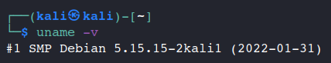

Usage: Deployment Environment

- Node and NPM

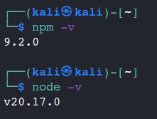

Usage: Node.js Backend

- Nmap.

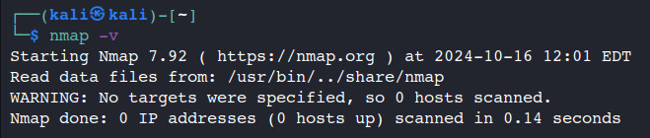

Usage: Network scanning to detect open ports and vulnerabilities on endpoints.

- OSQuery:

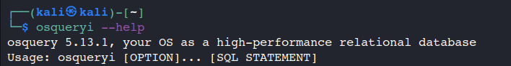
Usage: Endpoint monitoring via queries to gather system configurations and security data.

- Tshark:
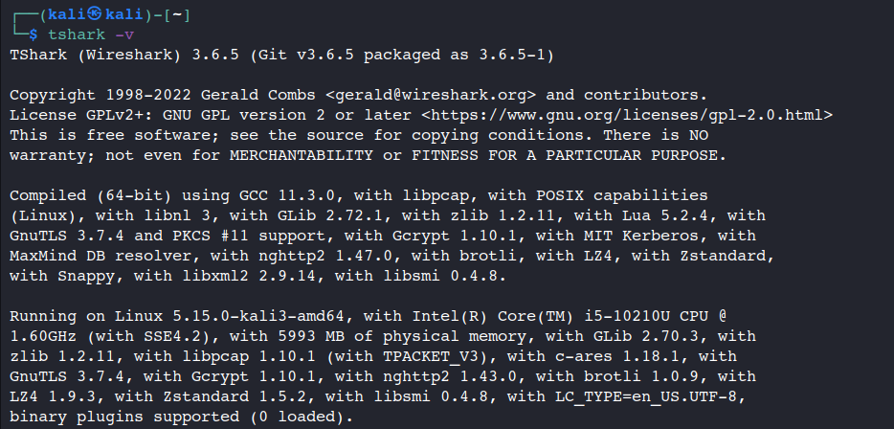

Usage: Analyze network traffic to detect unusual or unauthorized activity.

- Tcpdump:

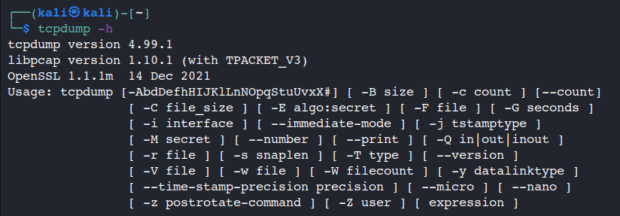

Usage: Command-line tool for detailed network traffic analysis on endpoints.

- Squid Proxy:
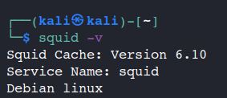

Usage: Monitor and log network traffic from endpoints to detect suspicious activity.

- Zap (Zed Attack Proxy):
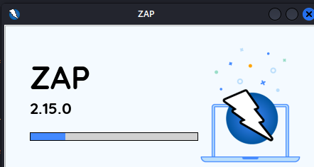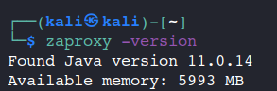

Usage: Scan web interfaces for vulnerabilities like SQL injection and XSS.

- SQLMap:
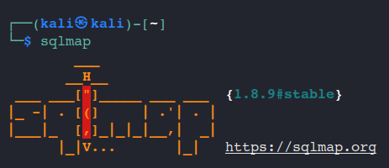

Usage: Test endpoints for SQL injection vulnerabilities in web applications.

- OWASP Dependency-Check:
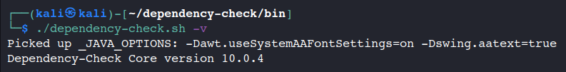

Usage: Scan software dependencies for known vulnerabilities.

- Prowler:
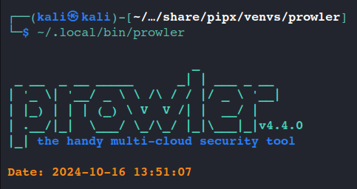

Usage: Audit cloud configurations for security best practices on endpoints accessing cloud resources.

- Git

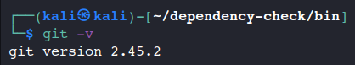
Usage: Source code Version Control

Deployment Platform

<Find a free hosting service where you can deploy your prototype for anyone to access online>

ACASA is designed for deployment on an enterprise's local server with functionality that includes compliance checklists and executable files for local auditing. We will use a hybrid deployment strategy to demonstrate the prototype online and simulate the final environment.

- Heroku for Prototype Deployment (Checklist and Document Uploads)
For the prototype, Heroku will be used to deploy the compliance checklist and document upload features. This allows stakeholders to access the ACASA dashboard online, mark compliance, and upload documents for review.

- Virtual Linux Image for Local Simulation and Online Distribution
To simulate ACASA’s final deployment in an enterprise environment, we will create a virtual Linux image that mimics the IT manager’s server. This image will include the web server (Apache/Nginx), PostgreSQL database, and secure APIs. Users will be able to:

Download and run a customized executable for local audits.
Send the gathered audit data back to the local web app via API.
Additionally, this virtual image will be uploaded to an online platform (e.g., Google Drive, Dropbox) for easy access. Testers and reviewers can download and run the virtual machine locally, providing a realistic simulation of the final deployment.

Benefits:
- Heroku offers online access to the prototype for easy feedback and testing.
- The virtual Linux image simulates the full local deployment, available for download and testing in enterprise-like environments.

Risk Management

Potential Risks and Mitigation Strategies

<List down top 10 potential risks and their mitigation strategies>

Sr. | Risk Description | Mitigation Strategy
 | Changes in compliance standards affecting system requirements | Implement a flexible architecture to allow updates to compliance rules
 | Vulnerability in document storage and handling | Use secure document encryption and database security practices
 | Delays in feature integration or system updates | Maintain a modular system allowing easy addition of features or updates
 | Issues integrating multiple external APIs | Start API integration early and conduct regular tests
 | Difficulty gathering feedback from compliance officers | Engage users early and conduct regular feedback sessions
 | Large datasets affecting system performance | Optimize database queries and implement caching mechanisms
 | Network security risks during testing | Perform regular vulnerability scans using tools like Nmap and Wireshark
 | Miscommunication between frontend and backend during integration | Maintain clear API documentation and implement automated integration tests
 | Data loss during deployment or updates | Implement backup and recovery solutions, including version control and off-site backups
 | Misuse of user credentials or unauthorized access | Implement multi-factor authentication and regular security audits

Who Did What?

Name of the Team Member | Tasks done
Ammad Akram | Analyzed pros and cons of processes in Software Process Selection and contributed to Risk Management (security risks).
Shabbir Kamal | Led Risk Management (network security risks) and refined the Gantt Chart (security tasks, milestones).
Aqdas Rizvi | Designed the Gantt Chart and contributed to Development Environment Preparation (tools setup).
Rida Bilgrami | Drafted the Deployment Platform section and documented compliance-related risks in Risk Management.

Review checklist

Before submission of this deliverable, the team must perform an internal review. Each team member will review one or more sections of the deliverable.

Section Title | Reviewer Name(s)
Software Process Selection | Ammad Akram
Risk Management | Shabbir Kamal
Gantt Chart and Timeline | Aqdas Rizvi
Deployment Platform and Compliance | Rida Bilgrami

